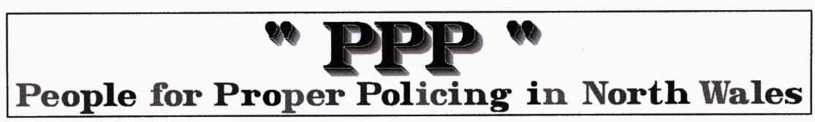
FOI helps the Police police themselves Martin Rosenbaum 19 Dec 2006

South Yorkshire Police prosecuted South Yorkshire Police because South Yorkshire Police can't tell South Yorkshire Police which South Yorkshire Police officer was driving a speeding vehicle being used by South Yorkshire Police.

This follows BBC reporter Martin Shankleman's determined use of freedom of information in pursuit of cases where Police vehicles are caught speeding by speed cameras, but no driver is prosecuted - because the Police can't establish which one of their officers was doing the driving at the time. His revelations of such cases have featured on Newsnight, firstly in September and then again December.

South Yorkshire's Chief Constable Meredydd Hughes told Newsnight that 'since Mr Shankleman brought this matter to my attention, we've reiterated the rules, issued national guidance, brought the disciplinary matters to the attention of the officers concerned and for the first time prosecuted ourselves.' So in other words BBC reporter uses freedom of information to find out and tell the Chief Constable what's going on within his own organisation. Chief Constable Hughes is the traffic safety spokesman for the Association of Chief Police Officers. This is the list of instances where his force was unable to identify the Police officer driving a speeding vehicle.

Vehicle Speed Date Speed Limit Location
Unmarked car 37mph 20.4.2003 30mph Nutwell Lane, Doncaster
Unmarked car 60mph 1.5.2003 40mph Chesterfield Road South, Sheffield
Unmarked car 37mph 4.5.2003 30mph High Street, Rawmarsh
Unmarked car 59mph 10.10.2003 40mph Chesterfield Road South, Sheffield
Unmarked hire car 38mph 9.3.2005 30mph Broomhouse Lane, Edlington
Unmarked car 37mph 3.4.2005 30mph Halifax Road, Sheffield
Marked van 51mph 14.4.2005 30pmh Fenton Road, Rotherham
Unmarked car 35mph 22.4.2005 30mph High Street, Rawmarsh
Marked car 61mph 27.4.2005 50mph Parkway, Sheffield
Unmarked car 48mph 6.5.2005 30mph Urban Road, Doncaster
Unmarked car 46mph 13.7.2005 30mph Fenton Road, Rotherham
Unmarked hire car 37mph 28.7.2005 30mph Highgate Lane, Bolton-on-Dearne
Unmarked car 48mph 27.1.2005 40mph Carr House Road, Doncaster
Marked pick-up 36mph 10.3.2005 30mph Sandygate, Wath-upon-Dearne
Unmarked car 46mph 22.4.2005 40mph Parkway, Sheffield
Unmarked car 49mph 2.9.2005 40mph Mexborough By-pass, Mexborough
Unmarked car 50mph 13.12.2005 40mph New Wortley Road, Rotherham
Unmarked hire car 61mph 14.12.2005 50mph Centenary Way, Rotherham
Unmarked car 64mph 15.01.06 50mph M18 Rotherham
Unmarked car 60mph 08.02.06 50mph Centenary Way, Rotherham
unmarked car 47mph 17.05.06 40mph Bawtry Road, Rotherham
The PPP comments…this CC obviously doesn’t see the need to keep his own house in order or even know where his officers and vehicles are. Another joke ACPO ‘leader’

